Experiment: 4
Create and configure storage services and upload files and objects using Amazon EBS, Amazon EFS and Amazon S3
Part-3: ELASTIC FILE SYSTEM (EFS)
- Login into AWS Account
Start Lab and Launch AWS Console Home
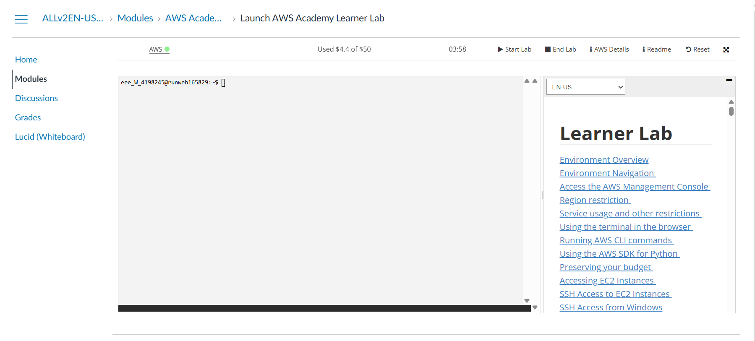
- Create an EC2 Instances namely
22bd1a057A_EFS_1
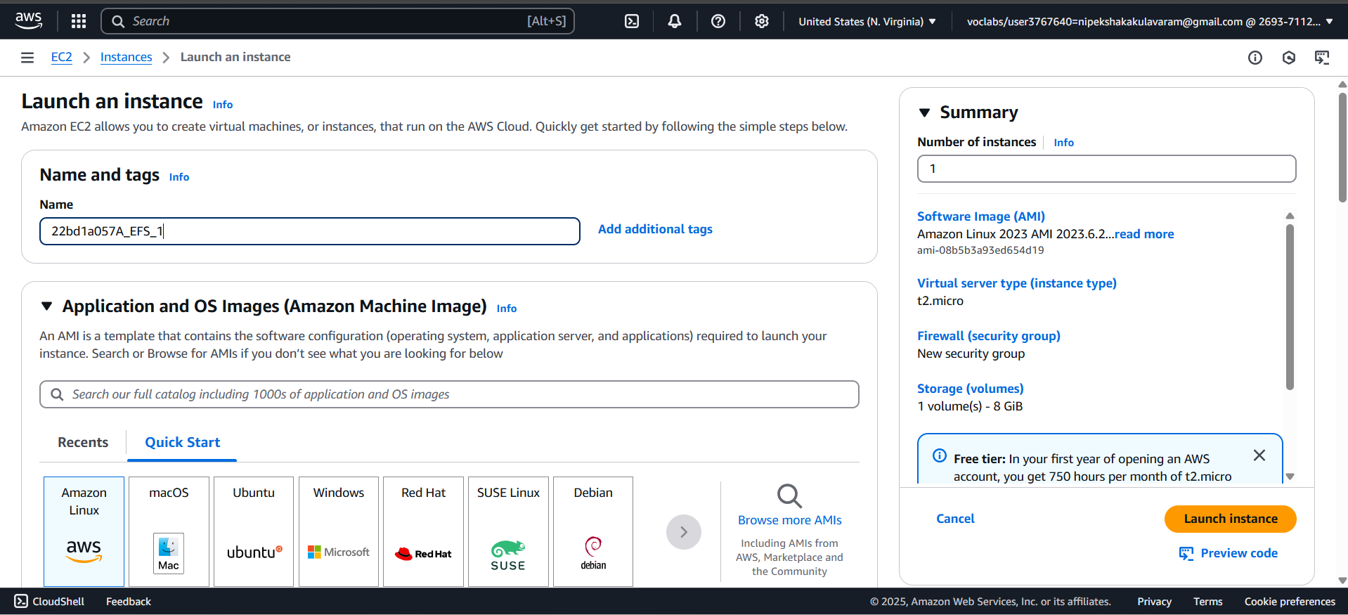

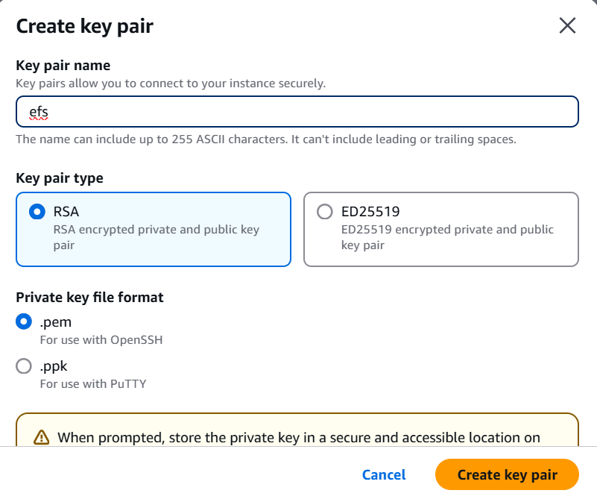

- Create second instance
22bd1a057A_EFS_2
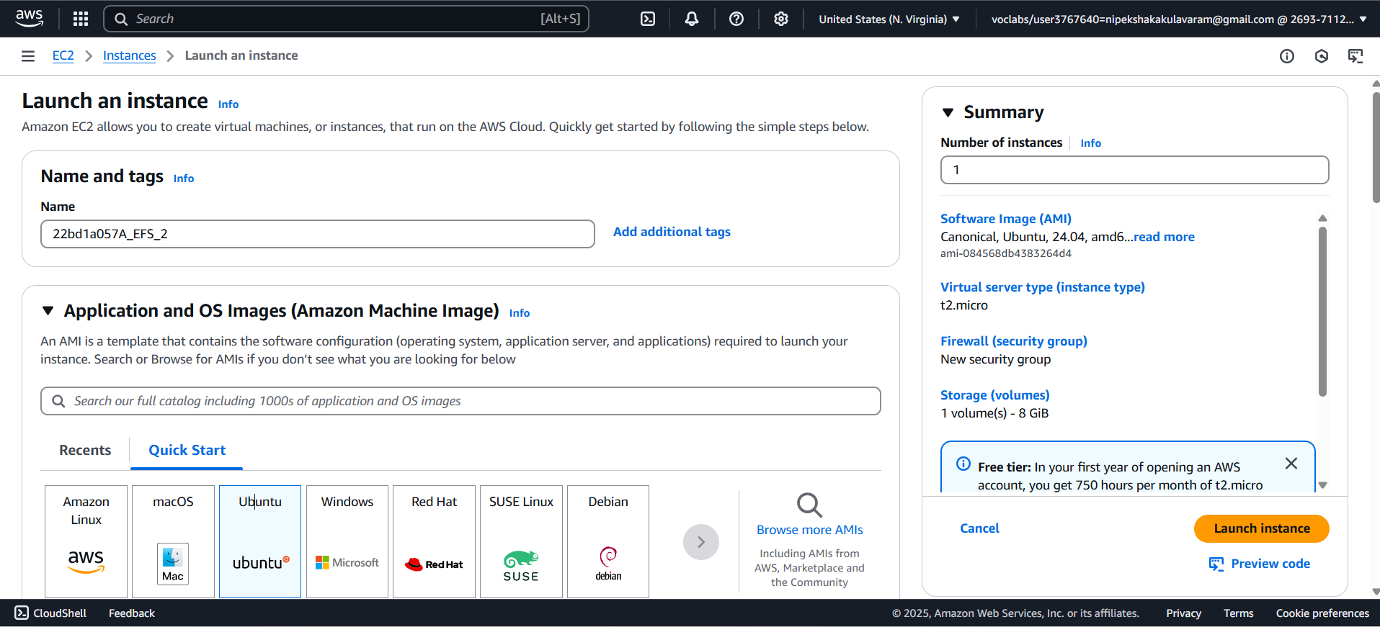

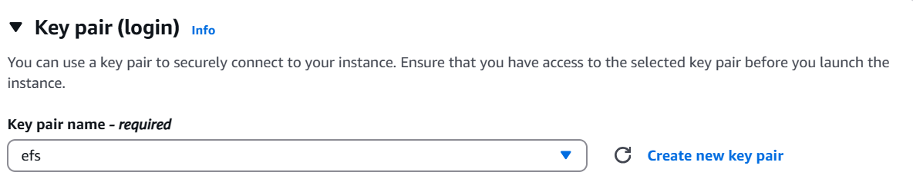

- The instances will be created as shown.
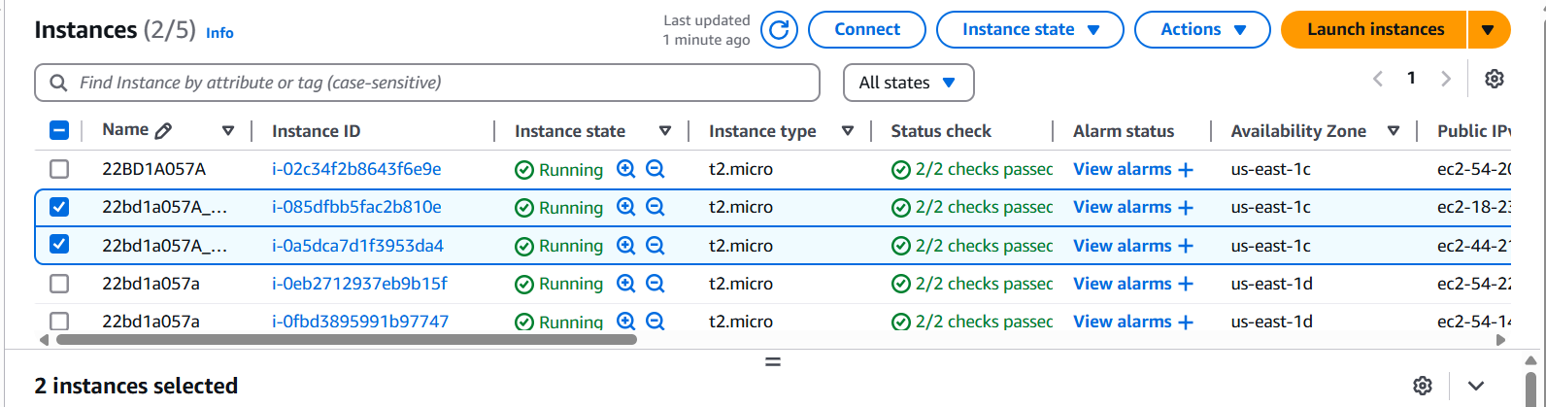

- Launch 2 Instance & Mount EFS File System.
EC2 Dashboard → Security Group → Create security Group
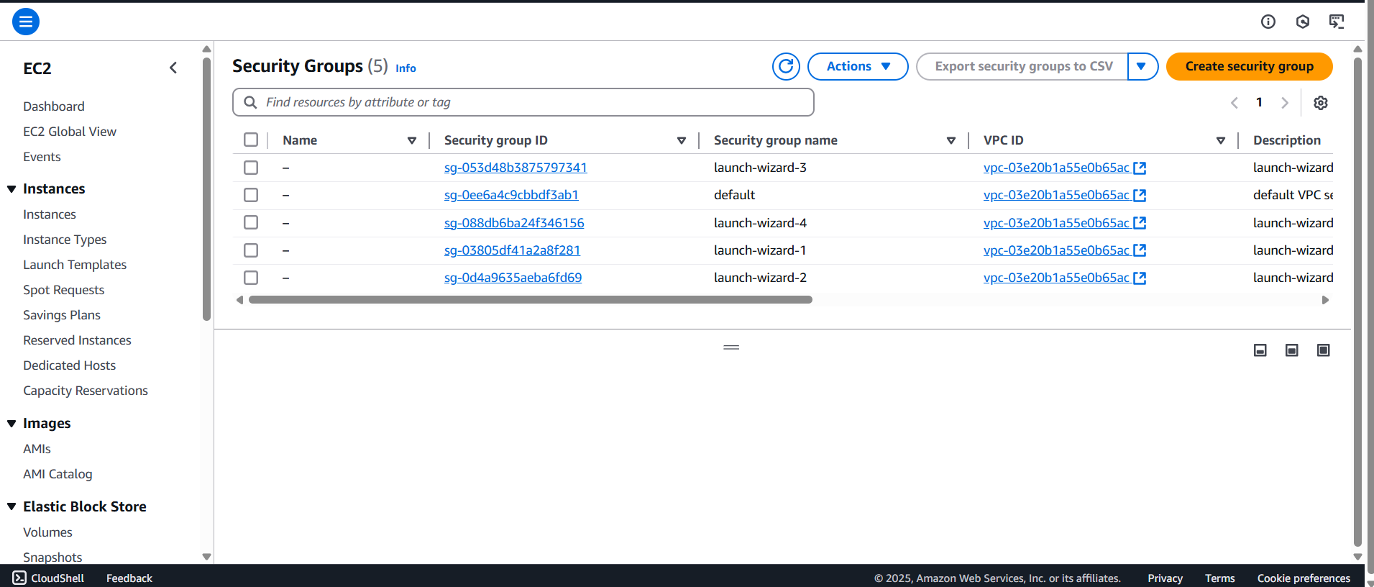

- Create security group.
Basic Details:
Security group name: 22bd1a057A_EFS
Description : EFS SG
VPC: Default
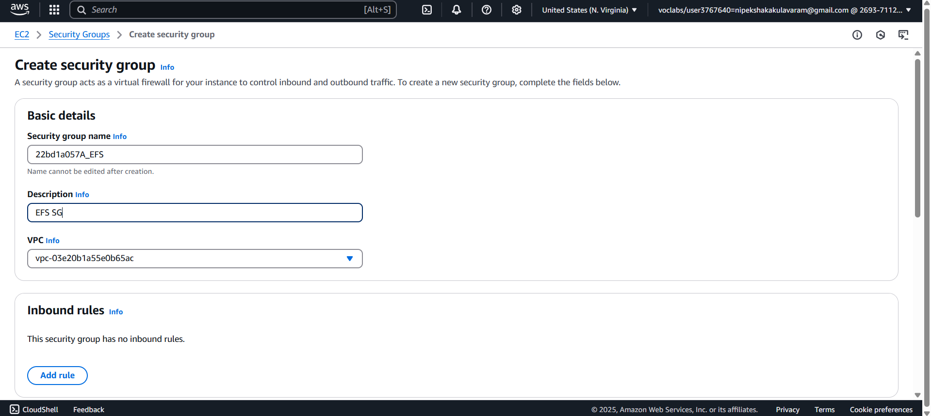

- Add Inbound Rules:
- Rule 1 & 2:
- Type: NFS
- Port Range: 2049
- Source: Custom
Select Security Group: (of Instance 1 & Instance 2)

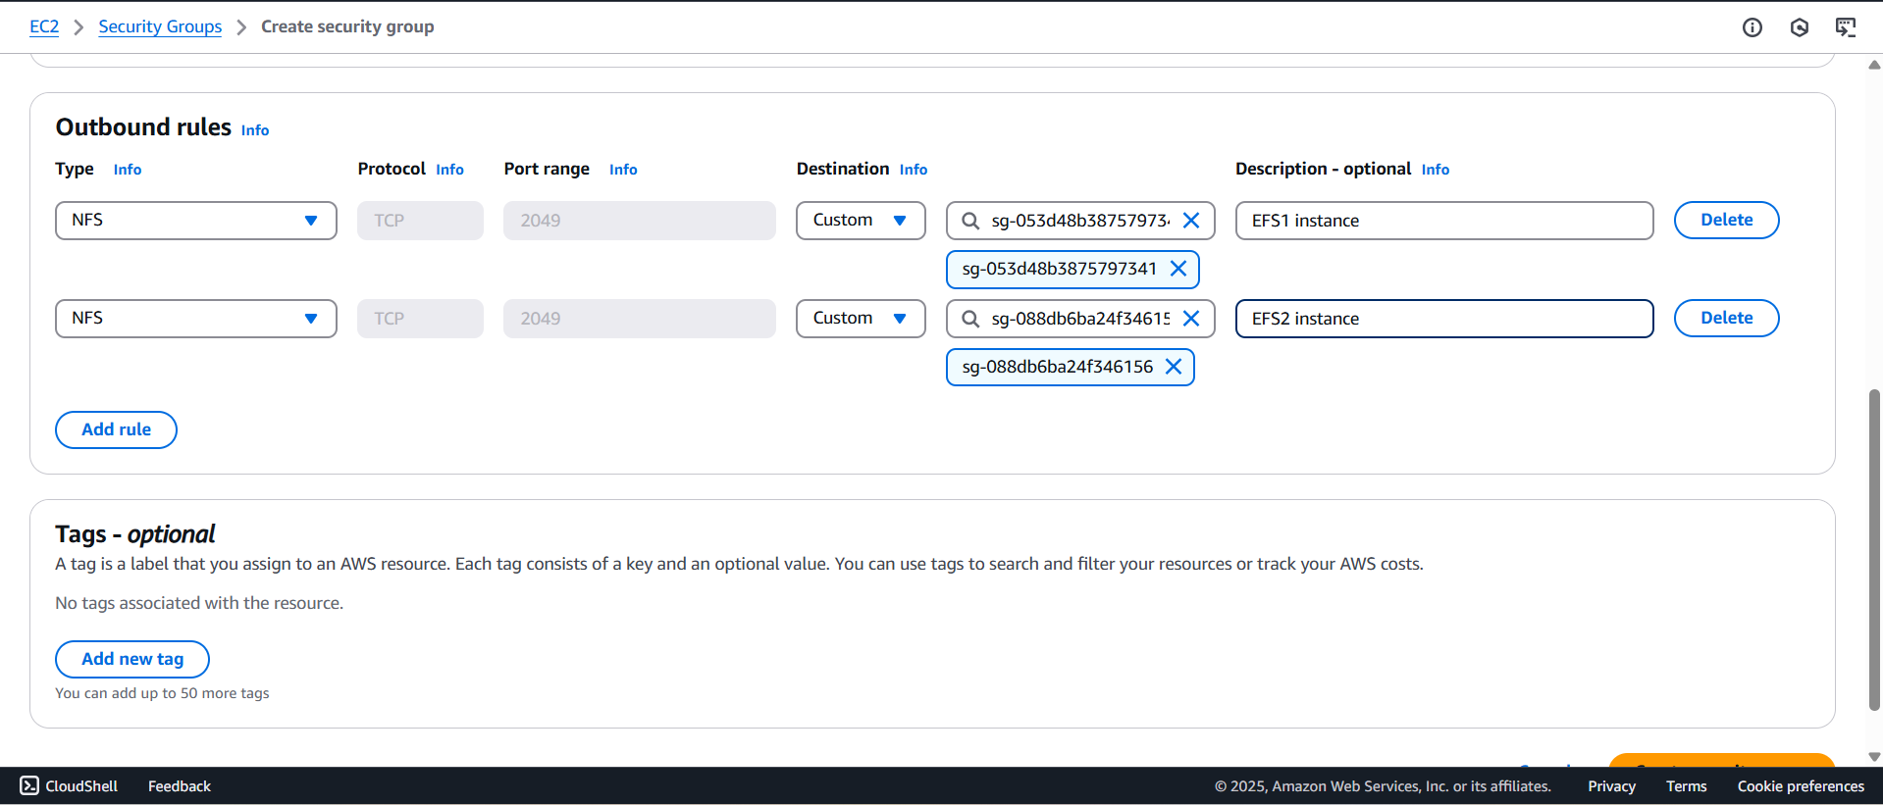

- Security group has been created as shown with name 22bd1a057A_EFS
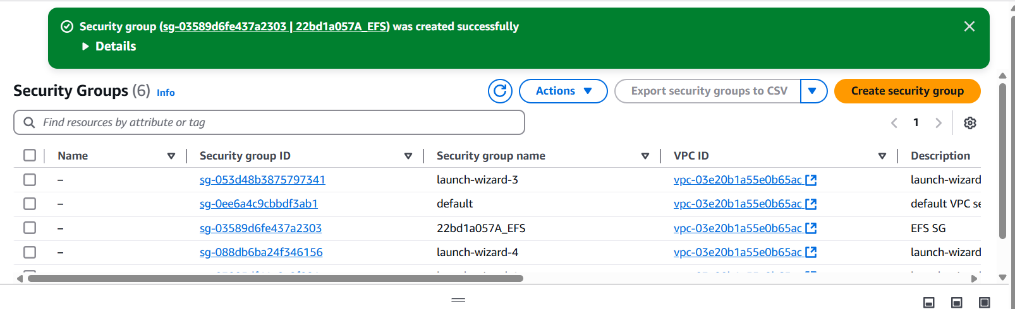

- Create an EFS File System
    - Go to AWS Console → Search "EFS" → Click Elastic File System.
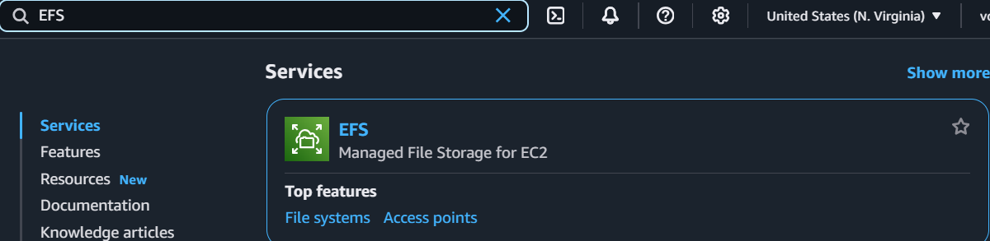

    - Click Create File System.
    - Enter Details:
Name: 22bd1a057a
VPC: Default (same as EC2 instance)
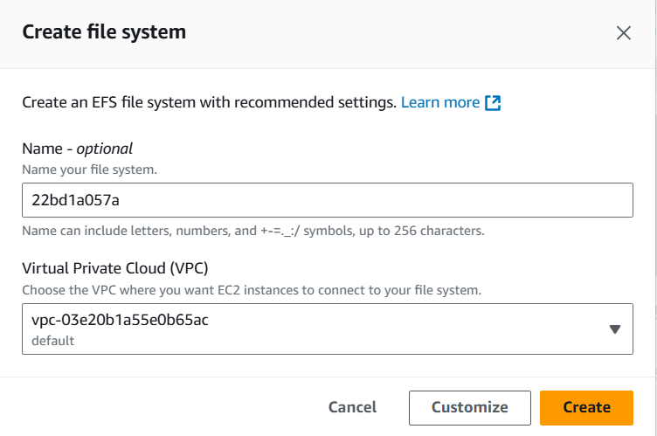
    - Storage Class: Regional
    - Enable automatic backups: Disable (Optional)
    - Lifecycle Management: 7 days (Move unused data to Infrequent Access)
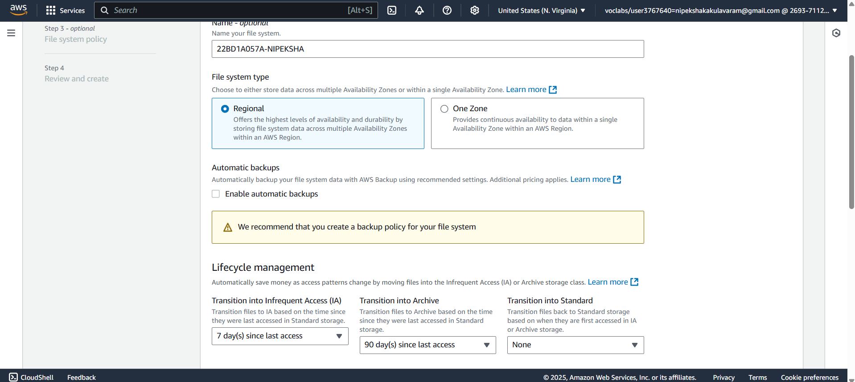
    - Encryption: Disable (Optional)
    - Performance Mode: General Purpose (Default)
    - Throughput Mode: Select Elastic (Recommended). Click on Next
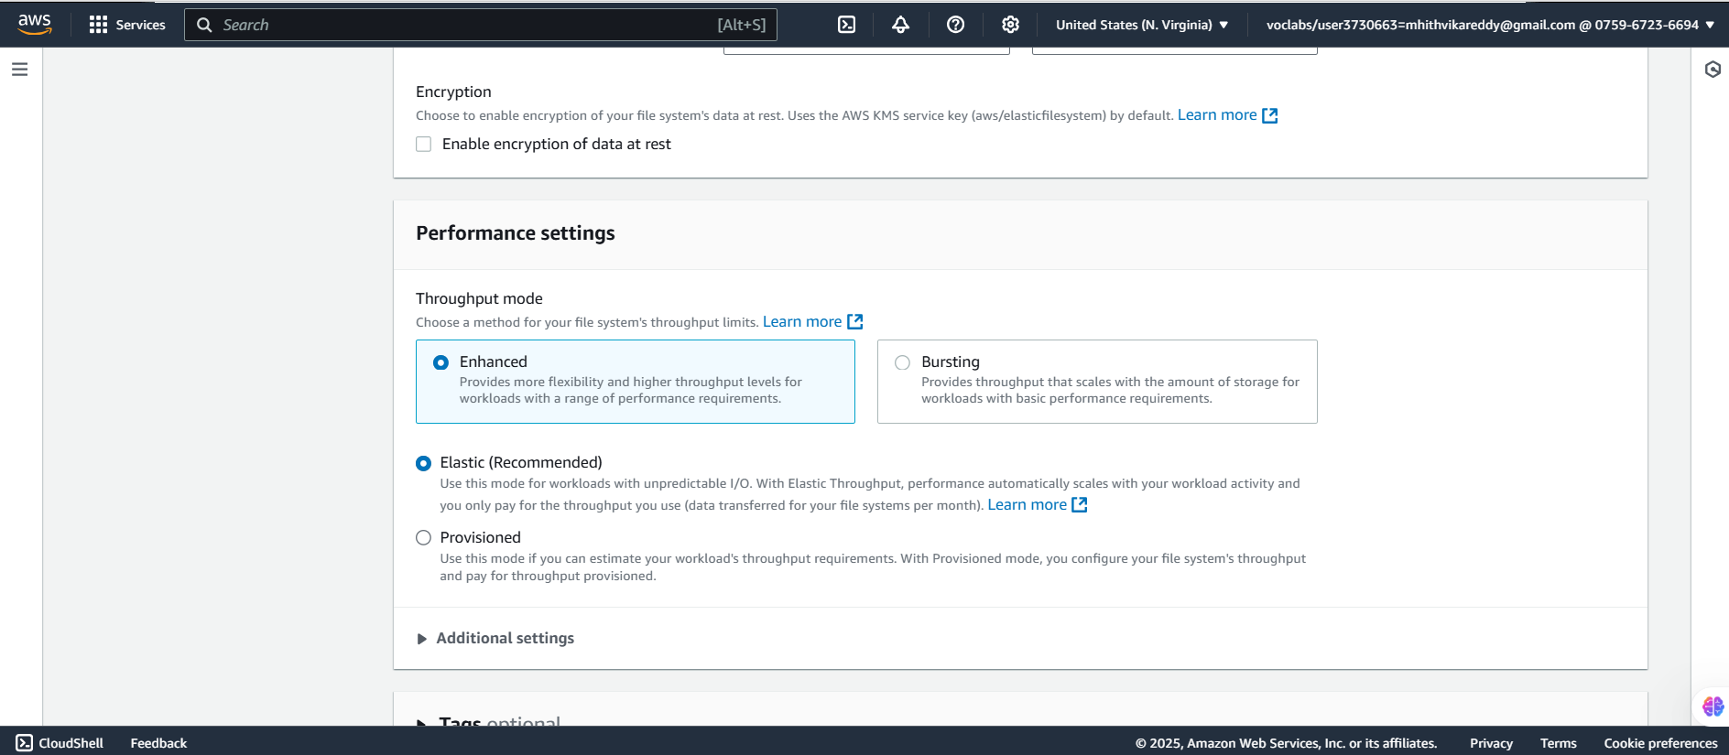
    - VPC: Select the same VPC
    - In Mount targets:
Availability zone of instances for me is us-east-1a. So for that I put security group as 22bd1a057a_EFS
I added default security groups for us-east-1b, us-east-1c by removing which were there
    - Click Next
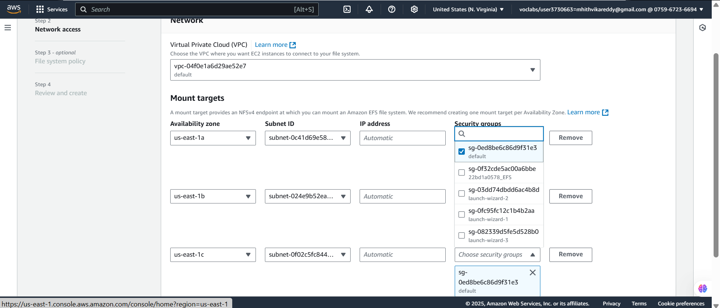

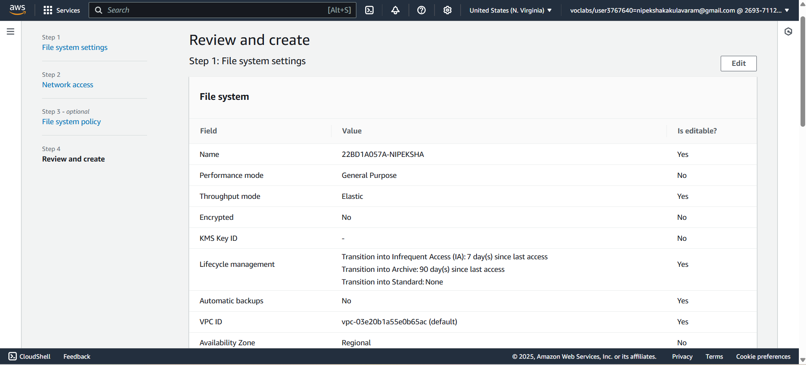

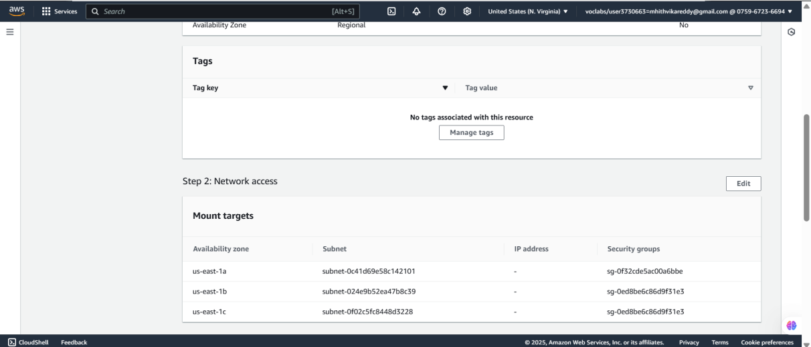

- Success!
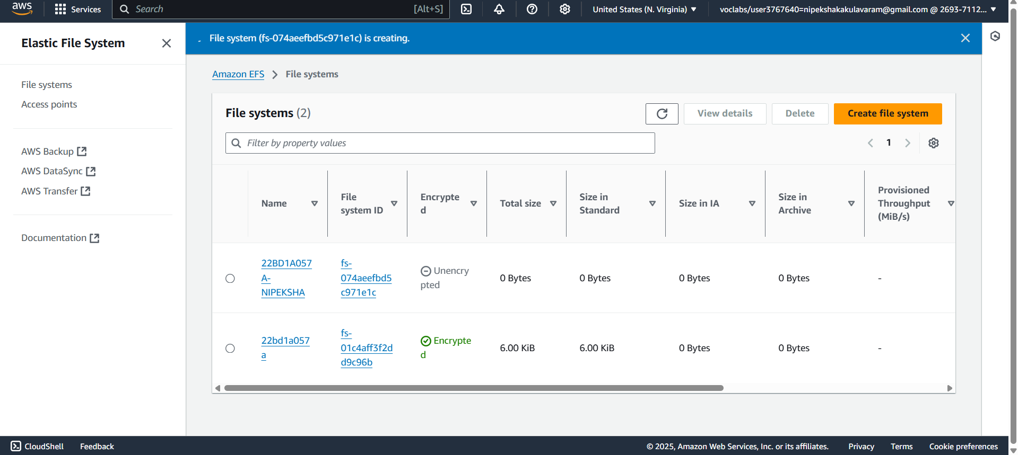
- Connect to Instance-1(Server1) from Putty using PEM File
    - Connect to Instance-1 (22bd1a057a_EFS1) using PuTTY or SSH
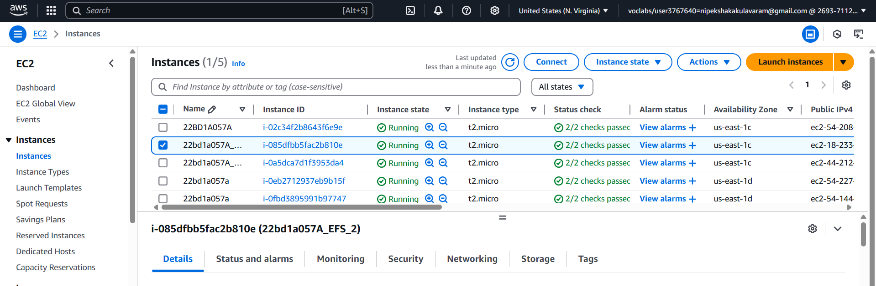

Click Connect
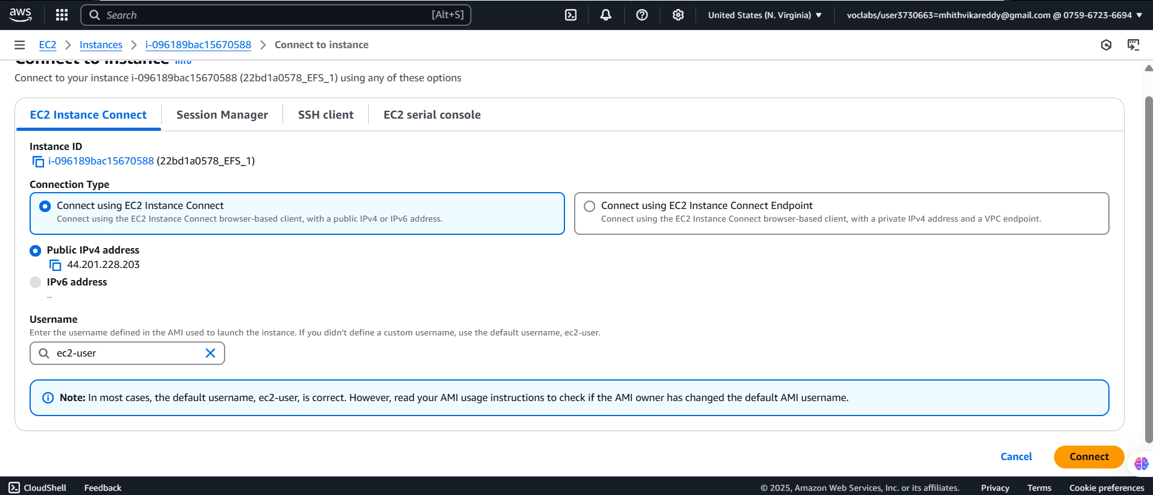

    - Switch to root by using sudo su
    - Install Amazon EFS utilities : yum install -y amazon-efs-utils

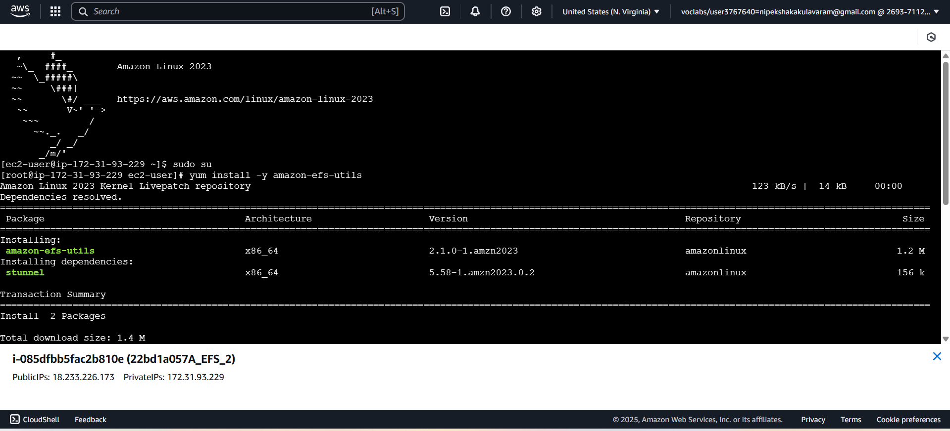
    - Create a directory using mkdir command for mounting
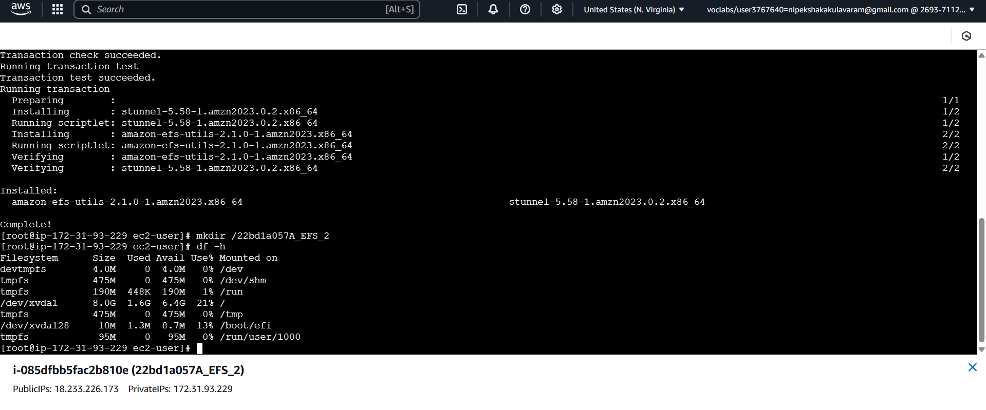
    - Mount the EFS:
Go to EFS Dashboard → Click on the created EFS →View Details →Attach

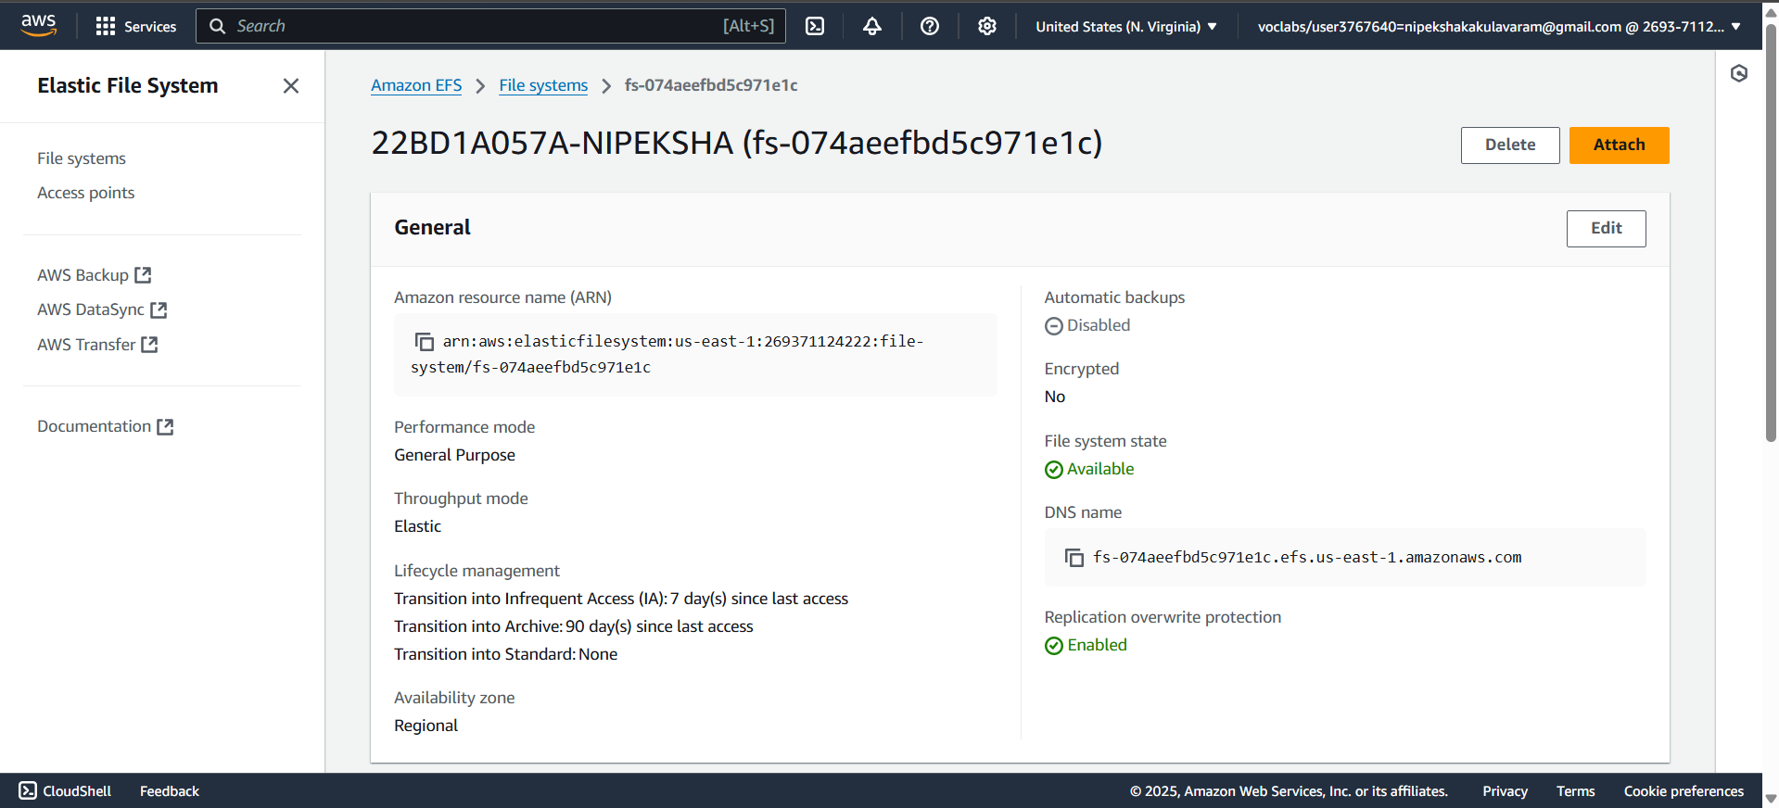
    - Copy the mount command (NFS Client method)
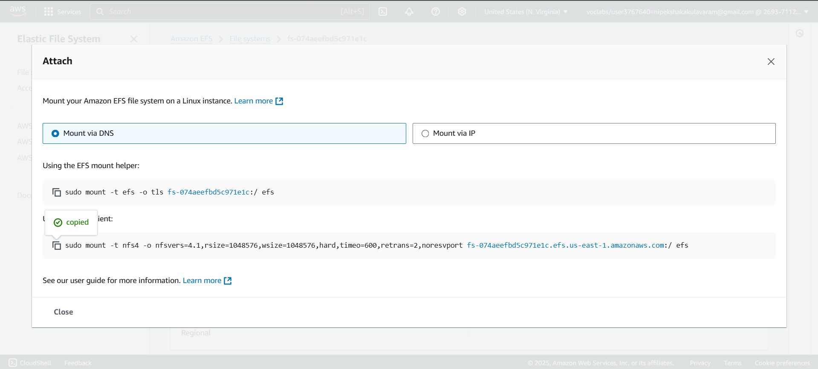
    - Paste in terminal by removing efs at last and adding your directory name as shown
sudo mount -t nfs4 -o nfsvers=4.1,rsize=1048576,wsize=1048576,hard,timeo=600,retrans=2,noresvport fs-0e24707cb4861ee39.efs.us-east-1.amazonaws.com:/ 22bd1a057a-EFS1

    - Verify the mount
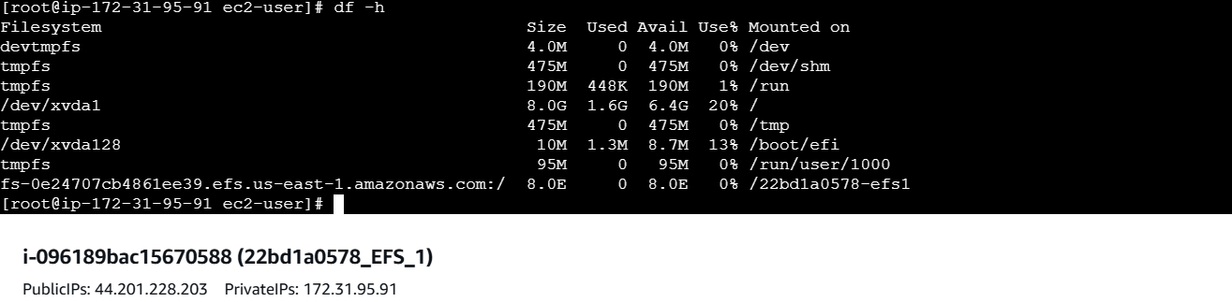
- Connect to Instance-2 from Putty using PEM File
    - Connect to Instance-1 (22bd1a057a_EFS1) using PuTTY or SSH
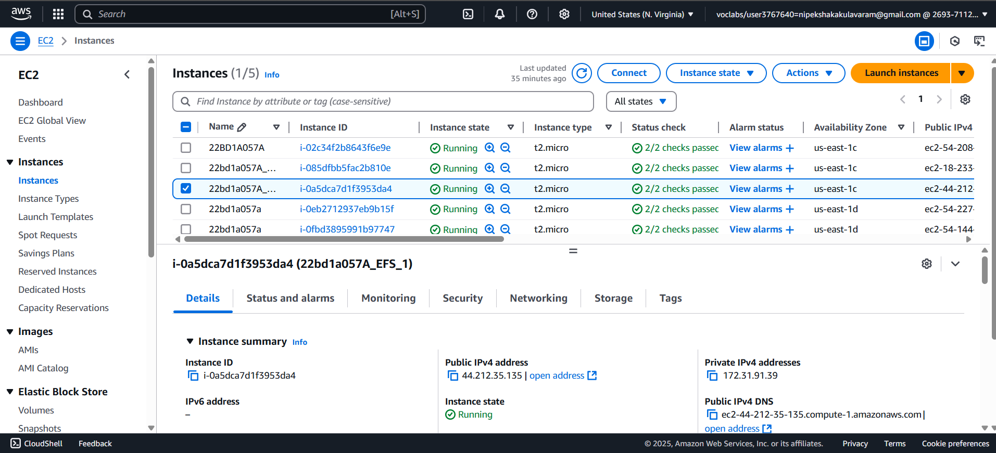

Click Connect
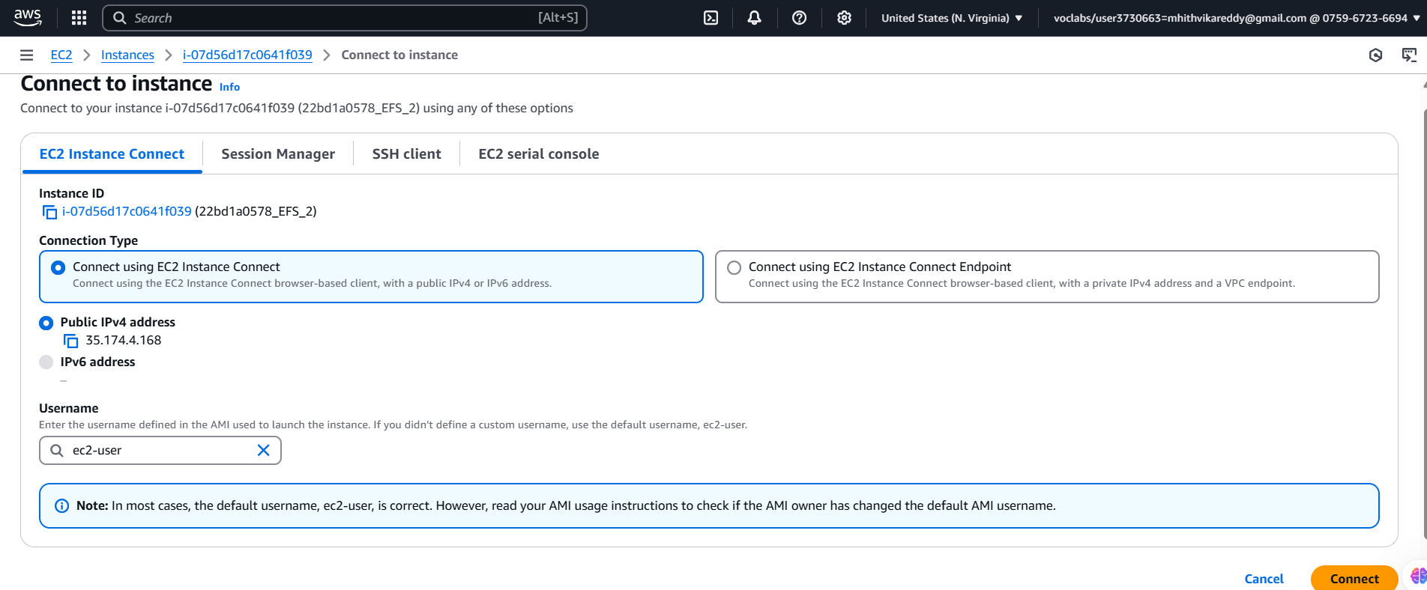
    - Switch to root by using sudo su
    - Install Amazon EFS utilities : yum install -y amazon-efs-utils
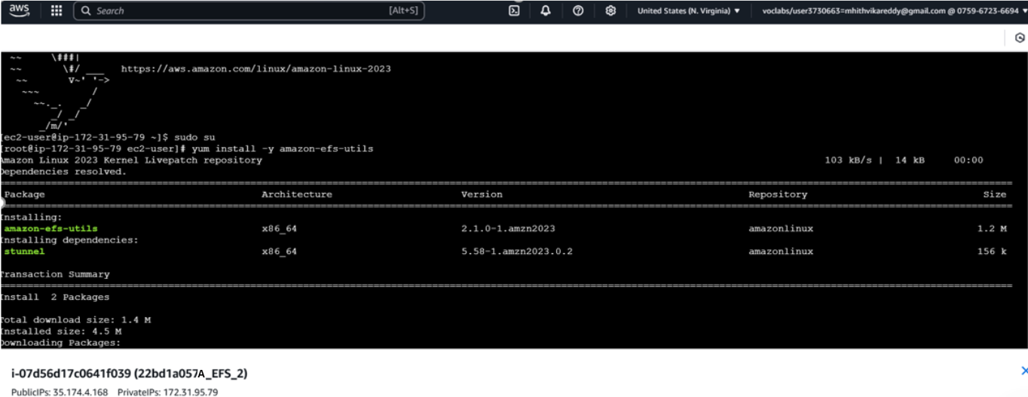
    - Create a directory using mkdir command for mounting
    - Mount the EFS using the similar command as Instance-1. sudo mount -t nfs4 -o nfsvers=4.1,rsize=1048576,wsize=1048576,hard,timeo=600,retrans=2,noresvport fs-0e24707cb4861ee39.efs.us-east-1.amazonaws.com:/ /22bd1a057a_efs2
    - Verify mount by df-h
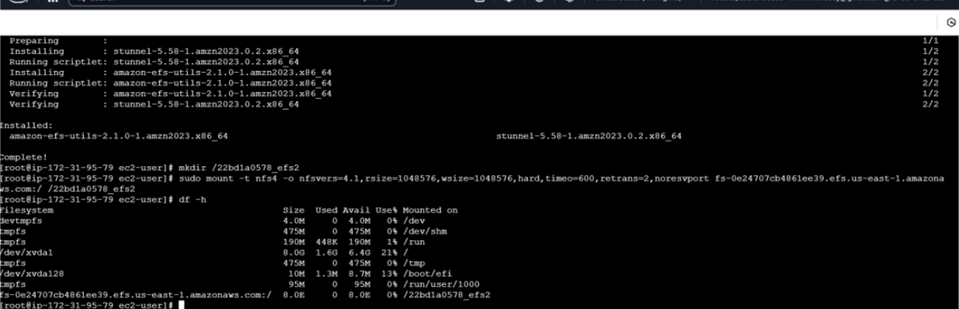

- Verify communication between instances
- Go to instance 1 terminal and enter commands as shown
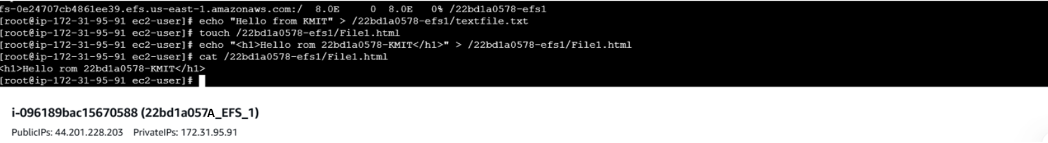

- Go to second instance ssh and enter commands as shown
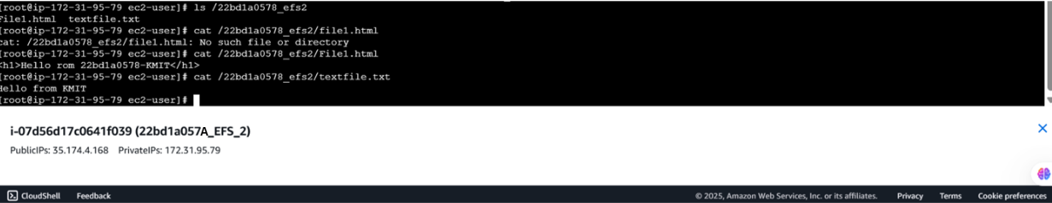

- End the lab.
